**Level Design Document for:**

*Night Walker*

All work Copyright ©2021

Written by Team AIE Production

Table of Contents

1.0 Revision History 4

2.0 level Design Overview 4

2.1 Level Design concept 4

2.2 Gameplay Mechanics 4

2.3 Camera 4

3.0 Theme and Characters 4

3.1 Characters 4

3.2 Theme 4

4.0 Level Information 5

4.1 Level Location 5

4.2 Level Setting 5

4.3 Level Layout/Architecture 5

5.0 Level Design 5

5.1 Main Objectives 5

5.2 Optional Objectives 5

5.3 WOW Moments 5

5.4 Level Progression 5

5.5 Player Experience 5

6.0 Art Style and Aesthetics 6

6.1 References 6

6.2 Lighting 6

6.3 SFX/Music 6

6.4 Particle FX 7

7.0 Level Asset List 7

8.0 Delivery Milestones 7

# Revision History

Revisions in response to feedback.

|  |  |
| --- | --- |
| Version | Description |
| 1.0 | Initial document |
| 1.1 | Added clarification in asset list, added assets such as trash cans for realism. Changed level progression from a line to a Key/Lock system. |
| 1.2 | Added pathways for enhanced realism. |
| 1.3 | Added streetlamps to help guide the player. Speed up player’s movement speed. Changed car collision so they can’t be run through to skip parts of the level. |
| 1.31 | Clarified that the game is a Walking Simulator and Explorer. |

# 2.0 level Design Overview

## 2.1 Level Design concept

The player wakes up in an empty city at night with all the city lights off apart from the Tower.

The game is a Walking Simulator and Explorer.

## 2.2 Gameplay Mechanics

* Walking
* Running
* Jumping

## 2.3 Camera

First person camera

# 3.0 Theme and Characters

## 3.1 Characters

Player Character – Reincarnation of Amaterasu, must bring light back to the world at the end.

Susanoo – Guide for the player, lights up the Tower.

Tsukuyomi – Moon Goddess, responsible for the eternal night

## 3.2 Theme

The world is plunged in darkness with no people around or any light apart from the Tower.

# 4.0 Level Information

## 4.1 Level Location

City Streets

## 4.2 Level Setting

The level is set at night on the city streets and alleyways. While cars still litter the streets people are nowhere to be found. The only light sources are from the dim streetlamps, stars and the Tower.

## 4.3 Level Layout/Architecture

The architecture of the game are a bunch of buildings and road close to the Tower.

Example of map:

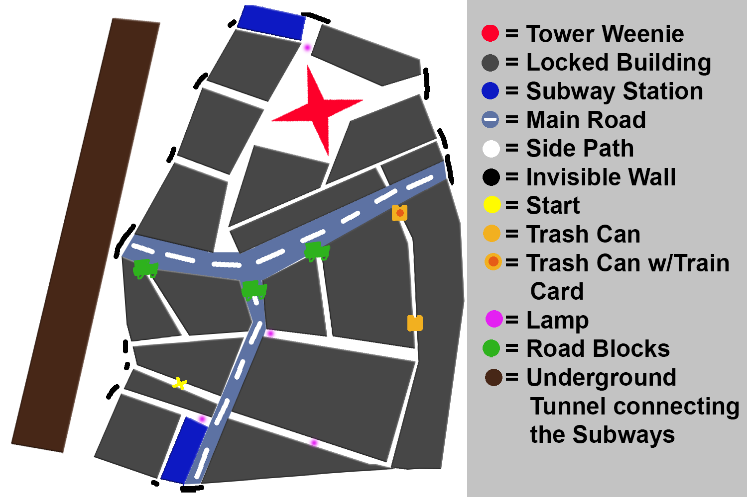

# 5.0 Level Design

## 5.1 Main Objectives

The main objective of the game is to find out what happened to the city and either return the original city or restore the current one to how it should be. The game is progressed by choosing a path and walking down it until the player reaches where they want to explore or the end of the level.

## 5.2 Optional Objectives

Optional objectives include areas where the player can stray off the beaten path to find secrets and learn more about what happened to the world.

## 5.3 WOW Moments

Walking out from the side of a building and the Tower lighting up the world.

## 5.4 Level Progression

Possible main progression paths the player could take

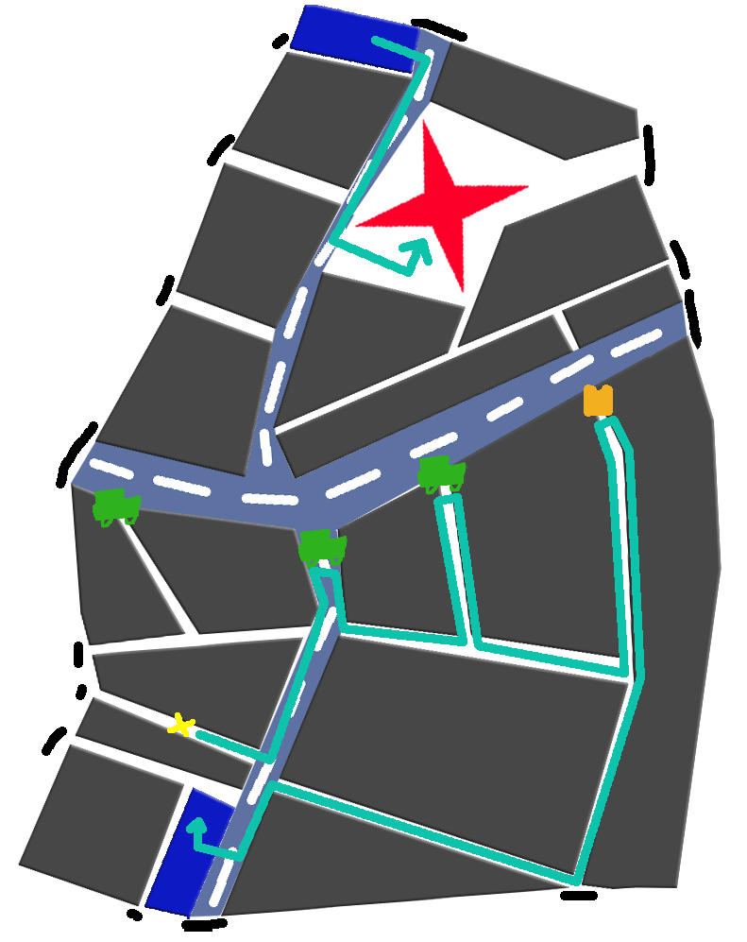

*The player is blocked off in the lower half until they find a subway ticket in the trash which lets them into the Subway station. The player can then walk on the rails to get out on the top half.*

## 5.5 Player Experience

*The main motivation for the player is to find out what happened to the world and the eventually to bring day back.*

There are no enemies in the first area to keep the feeling of the player being truly alone at the start.Eventually the player would get their sun powers back and fight enemies.

# 6.0 Art Style and Aesthetics

## 

## 6.1 References

<https://petapixel.com/assets/uploads/2012/12/thierrydarkened-2.jpg>

<https://i.imgur.com/c82LgKw.jpg>

<http://media.techeblog.com/images/no-light-pollution-sky.jpg>

<http://grist.org/wp-content/uploads/2013/01/thierry_cohen_rio.png?w=470>

## 6.2 Lighting

Greys and blues colours, dark and lonely lighting, the moon and the tower are the only light sources illuminating the city guiding player towards the Tower.

## 6.3 SFX/Music

A sombre track plays as the player explores the world

Footsteps are used as the player walks.

## 6.4 Particle FX

A strong wind and clouds cycles over the top of the Tower.

# 7.0 Level Asset List



# 8.0 Delivery Milestones

* Level Design Document – 9/8/22
* Greybox – 10/8/22
* Buildings – 10/8/22
* Roads – 11/8/22
* 3D Modelled Tower – 12/8/22
* Trash can – 13/8/22
* Ticket – 13/8/22
* Lamps and lighting – 14/8/22
* Guide character – 15/8/22
* Cars – 15/8/22
* Prototype – 16/8/22
* Others testing/feedback phase 16/8/22
* Fixing 16/8/22
* Test 2 17/8/22
* Final Build 18/8/22

I had more problems than expected with 3D modelling making it take longer than expecting and leading the Guide Character to be cut from development.